# Display property in CSS

## Block level elements

Div is an example of block level element. So, each such element will take the entire width.

### display: inline:

To make any such element inline we should do:

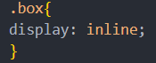

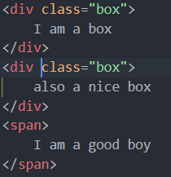

In the above code we see that we have made display inline. And then we have added two block level elements and one inline

The result =>



Drawbacks:

* Padding and margins are applied vertically not horizontally.
* Width and height cant be set explicitly

### display: inline-block:

There are some drawbacks to inline that are handled by inline-block.

## Inline elements

They only take the required space. And appear next to each other if space is there

display: none; this means that the space along with content of the element will be removed

visibility: hidden; this means that the content will be hidden but space occupied will still be occupied as empty

<https://developer.mozilla.org/en-US/docs/Web/CSS/display>